Review: The Vikings in Cleveland

Edited by Heather O’Donoghue and Pragya Vohra

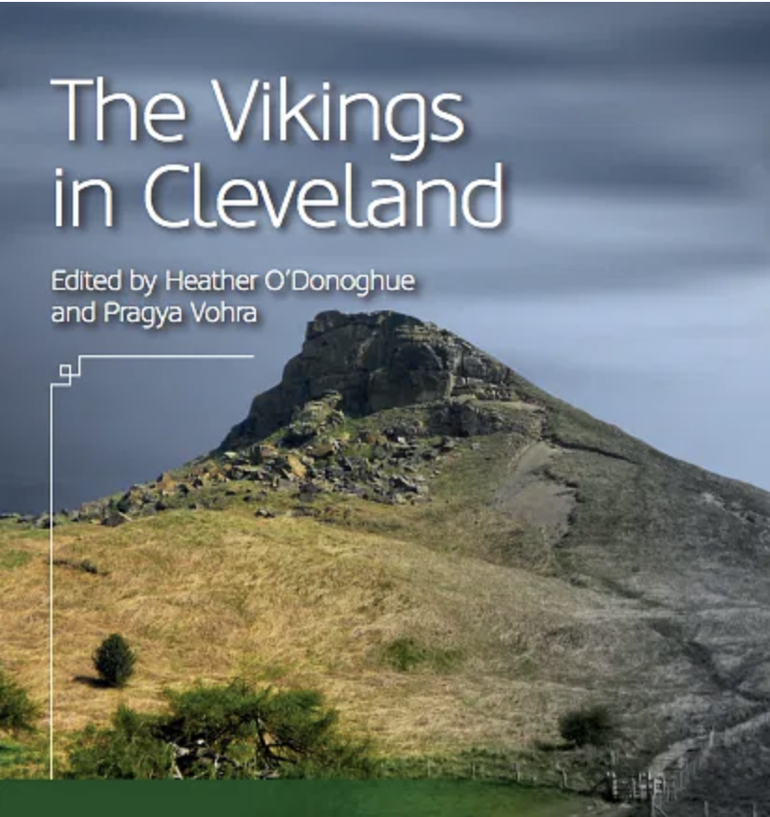
Introduction

The Vikings in Cleveland is an ambitious exploration of the often-overlooked Viking Age history of Cleveland and the Tees Valley. Edited by Heather O’Donoghue and Pragya Vohra, the work is part of the broader Languages, Myths, and Finds Project, which seeks to uncover the Scandinavian legacy across Britain and Ireland. The book positions Cleveland as a key borderland of Viking influence, presenting it as a distinct cultural and historical region that has long been overshadowed by more prominent Viking settlements such as York. By weaving together archaeological findings, linguistic studies, folklore, and local perceptions, the contributors offer a multifaceted understanding of Cleveland’s Anglo-Scandinavian heritage.

The volume includes contributions from scholars specializing in various disciplines, such as place-name studies, linguistic heritage, and medieval literature. Together, these chapters aim to redress Cleveland’s marginalization in Viking studies and highlight its unique cultural identity as a frontier region between Anglo-Saxon Northumbria and the Scandinavian-controlled Danelaw. Through case studies of local landmarks like Roseberry Topping and artifacts like hogback stones, the book provides both academic rigor and community-focused insights.

2. Scandinavian Settlement in Cleveland (Jane Harrison)
Jane Harrison’s chapter delves into the archaeological and environmental evidence of Scandinavian settlement in Cleveland, beginning around AD 876. She highlights the adaptability of the settlers, who exploited the region’s diverse landscape for farming, fishing, and trade. Scandinavian settlers integrated into the local church structures and adopted some Anglo-Saxon building styles, while maintaining distinct cultural markers, such as hogback monuments.

The chapter emphasizes Cleveland’s role as a frontier region, where Norse settlers navigated a complex political landscape between the Anglo-Saxon Church to the north and the Scandinavian rulers of York to the south. Harrison also discusses the burial practices at Kildale, which reflect both pagan and Christian influences, illustrating the cultural hybridity of the region.

Harrison’s analysis of hogback stones is particularly compelling. These carved stones, which resemble Viking long-houses or local hills, serve as symbols of power and authority. Cleveland’s abundance of these monuments suggests a localized development of Anglo-Scandinavian identity, challenging the notion that such cultural expressions were confined to major urban centers like York.

2. Scandinavian Settlement in Cleveland (Jane Harrison)
Jane Harrison’s chapter delves into the archaeological and environmental evidence of Scandinavian settlement in Cleveland, beginning around AD 876. She highlights the adaptability of the settlers, who exploited the region’s diverse landscape for farming, fishing, and trade. Scandinavian settlers integrated into the local church structures and adopted some Anglo-Saxon building styles, while maintaining distinct cultural markers, such as hogback monuments.

The chapter emphasizes Cleveland’s role as a frontier region, where Norse settlers navigated a complex political landscape between the Anglo-Saxon Church to the north and the Scandinavian rulers of York to the south. Harrison also discusses the burial practices at Kildale, which reflect both pagan and Christian influences, illustrating the cultural hybridity of the region.

Harrison’s analysis of hogback stones is particularly compelling. These carved stones, which resemble Viking long-houses or local hills, serve as symbols of power and authority. Cleveland’s abundance of these monuments suggests a localized development of Anglo-Scandinavian identity, challenging the notion that such cultural expressions were confined to major urban centers like York.

4. Dialect Heritage of Viking Age Cleveland (Nik Gunn)
Nik Gunn’s chapter examines the enduring influence of Old Norse on Cleveland’s dialect. Words like beck (stream), brant (steep), and ings (low-lying pasture) are linguistic remnants of the region’s Viking past. Gunn contextualizes these words within the broader “Great Scandinavian Belt” of northern England, where Old Norse had a profound impact on local speech.

The chapter also highlights the work of 19th- and 20th-century dialectologists, such as Reverend J.C. Atkinson and Professor Harold Orton, who documented Cleveland’s dialect and its Scandinavian elements. Gunn argues that these dialect words reflect the everyday concerns of Viking settlers, such as farming and navigating the landscape. The chapter is a testament to how linguistic heritage
illuminate the lived experiences of historical communities.

5. Viking Raids and Cultural Memory in Cleveland (Jo Shortt Butler)
Jo Shortt Butler explores Viking raids on Cleveland, focusing on two key events: King Harald Hardrada’s 1066 raid on Scarborough and King Eysteinn Haraldsson’s 1151–1152 coastal raids. While these events reflect the violent side of Viking interactions, Butler also examines the cultural memory of Vikings in Cleveland.

Folklore, such as the story of Vikings being deterred by Yorkshire puddings, and traditions like the Goathland sword dance, hint at a more nuanced relationship between Norse settlers and the local population. Butler also discusses modern efforts to engage with Viking heritage, such as the “Odin’s Glow” festival, which brought Topping’s Norse connections to life for local communities.

This chapter underscores the complexity of Cleveland’s Viking legacy, balancing narratives of violence with evidence of cultural integration and lasting influence.

6. Conclusion by Heather O’Donoghue
In her conclusion, Heather O’Donoghue reflects on Cleveland’s status as a borderland, caught between Anglo-Saxon Northumbria and Scandinavian-controlled York. She argues that this liminal position allowed Cleveland to develop a unique Anglo-Scandinavian culture, evident in its place-names, dialect, folklore, and carved stones.

O’Donoghue highlights the importance of Roseberry Topping as a symbol of this heritage, suggesting that it may have been a sacred site for Norse settlers. She also draws parallels between Viking Age Cleveland and the industrial growth of Teesside in the 19th century, where waves of migration similarly shaped a distinctive regional identity. The conclusion reinforces the book’s central argument: Cleveland’s Viking heritage, though understated, is a vital part of its history and cultural identity.

Critical Assessment

Strengths
The Vikings in Cleveland succeeds in bringing attention to an under explored region of Viking Age Britain. The interdisciplinary approach, combining archaeology, linguistics, folklore, and community engagement, provides a well-rounded perspective on Cleveland’s Anglo-Scandinavian heritage. The focus on Roseberry Topping as a symbolic and literal landmark is particularly effective, grounding the narrative in a tangible aspect of the landscape.

The book also excels in accessibility. Each chapter balances scholarly rigor with an engaging style, making it suitable for both academic and general audiences. The integration of local voices and community perspectives adds depth and relevance, highlighting the continued resonance of Viking history in Cleveland.

Limitations
Despite its achievements, the book occasionally struggles to connect its findings to broader Viking studies. While the focus on Cleveland’s distinct identity is valuable, a deeper comparison with other Viking settlements, such as York or Dublin, could have strengthened the analysis. Additionally, the reliance on limited archaeological evidence highlights the need for further excavation and research in the region.

The book also leans heavily on place-names and linguistic evidence, which, while informative, may not fully capture the lived experiences of Viking settlers. Greater emphasis on material culture, such as everyday artifacts, could have provided a more holistic picture of life in Viking Age Cleveland.

Conclusion

The Vikings in Cleveland is a significant contribution to Viking studies and regional history, offering a fresh perspective on an often-overlooked area. By uncovering Cleveland’s Anglo-Scandinavian heritage through place-names, dialect, and folklore, the book challenges traditional narratives that marginalize this borderland region. While there is still much to learn about Viking Age Cleveland, this volume lays a strong foundation for future research and underscores the importance of local history in understanding broader cultural phenomena.

This book is a must-read for anyone interested in the Viking Age, regional history, or the interplay between local and global narratives in shaping cultural identity.

See Link below:

https://www.nottingham.ac.uk/research/groups/csva/documents/lmfpublications/lmf4-cleveland,thevikingsincleveland.pdf

