The Three Trees
Once upon a mountain top, three little trees stood and dreamed of what they wanted to become when they grew up. The first little tree looked up at the stars and said: “I want to hold treasure. I want to be covered with gold and filled with precious stones. I’ll be the most beautiful treasure chest in the world!” The second little tree looked out at the small stream sparkling down the mountain and said: “I want to be a mighty sailing ship. I want to travel across the ocean and carry powerful kings. I’ll be the strongest ship in the world!” The third little tree looked down into the valley and said: “I don’t want to leave this mountaintop at all. I want to grow so tall that when people look at me, they’ll raise their eyes to heaven and think of God. I’ll be the tallest tree in the world!”
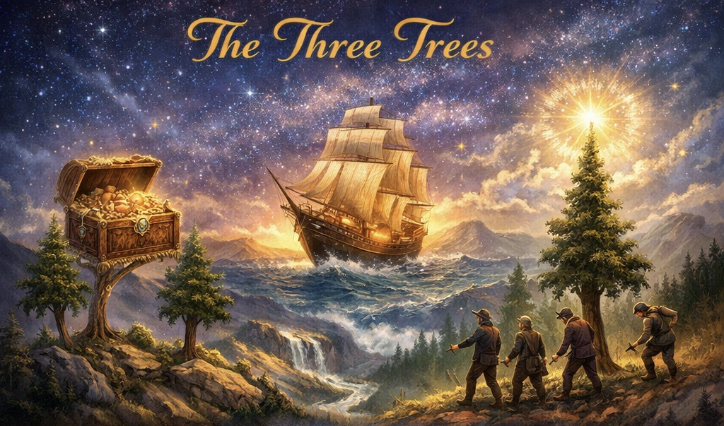
Years passed. The rains came, the sun shone, and the little trees grew tall. One day, three woodcutters climbed the mountain. The first woodcutter looked at the first tree and said, “This looks like a strong tree. I think I can sell its wood to a carpenter,” and he began cutting it down. The tree was happy, because it knew the carpenter would make it into a beautiful treasure chest.The second woodcutter said, “This tree is sturdy. I’ll sell it to the shipyard. The second tree was happy, because it was going to become a mighty ship.The third tree felt its heart sink when the last woodcutter came. It stood straight and tall, hoping someone would see how beautifully it pointed to heaven. But the woodcutter never even looked up. “This looks like a good, strong tree,” he said. “I can sell it to the lumberyard.” The third tree was frightened, for it knew its dream of staying on the hilltop would never come true.
The first tree was made into a simple feed box for animals and placed in a barn, filled with hay. The second tree was cut and made into a small fishing boat. The third tree was cut into large beams and left in a lumberyard.“What happened?” the once-tall trees wondered. “All we ever wanted was to be something great, and now look at us…”
Many years later, on a quiet night, a young woman and her husband entered the barn where the feed box stood. The woman gave birth to a baby and placed him gently on the hay inside the feed box made from the first tree. The tree could feel the importance of that moment. It knew it was holding the greatest treasure in the world: the Son of God. Some time after, a weary traveler and his friends crowded into the old fishing boat made from the second tree. The traveler fell asleep as they sailed, but soon a terrible storm arose. The tree thought it wasn’t strong enough to keep them safe. Then the traveler stood up, stretched out his hand, and said, “Peace, be still.” The storm stopped as quickly as it had begun. The second tree knew it had carried the King of kings. On a dark Friday many years later, soldiers took the beams from the lumberyard and fashioned them into a crude cross. They hung a man on it to die. The third tree felt ugly, harsh, and cruel. But on Sunday morning, when the sun rose and the earth trembled with joy beneath it, the third tree understood: the man who died there was God’s own Son, and now the whole world would look up at this cross and remember God’s love forever.
None of the three trees got what they first wanted…but each became part of something far greater than they had ever dreamed.
And that is how God often works in our lives too. 🌲✨

