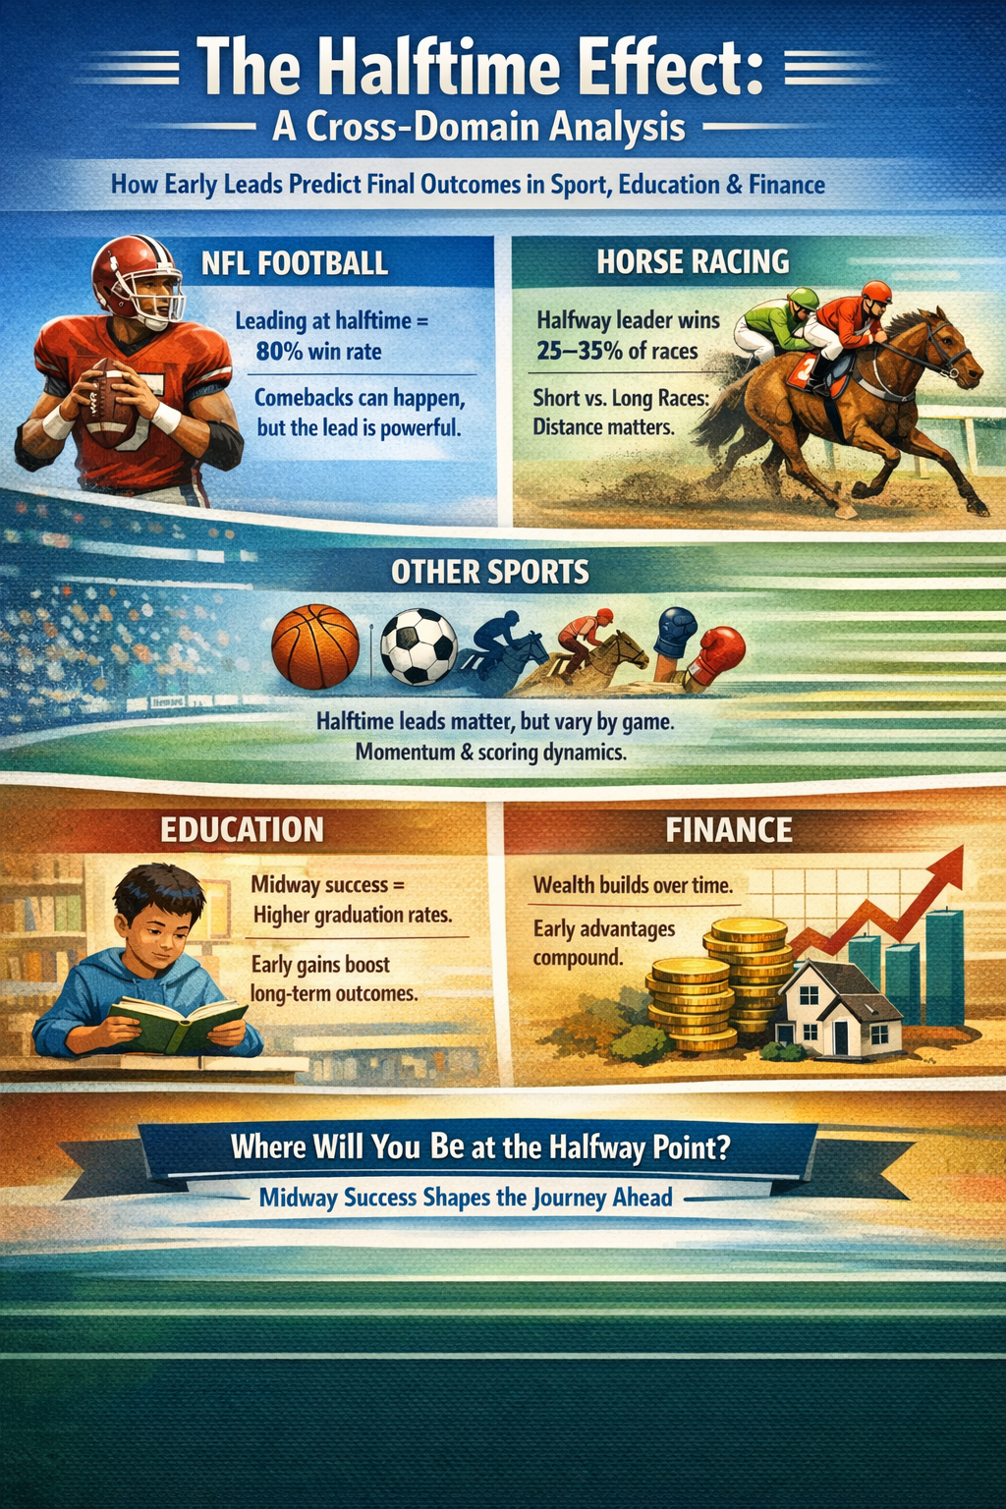
The Halftime Effect: A Cross-Domain Analysis

Exploring how early leads predict final outcomes across sport, education, finance, and beyond.

1. Football (NFL)

The team leading at halftime in the NFL wins approximately 80% of the time — a remarkably strong statistical relationship. The size of the lead matters significantly: a 3-point advantage is far less predictive than a 17-point lead. While comebacks from double-digit deficits do occur, they have become somewhat more common in the modern, pass-heavy era of the game, where points can be scored more quickly. Nevertheless, the halftime leader holds a commanding statistical edge.

2. Horse Racing

In horse racing, the halfway leader wins in roughly 25–35% of races. While this sounds modest, it is well above random chance in a typical 10-horse field (where chance alone would predict a 10% win rate). The relationship is more complex than in team sports: race distance matters enormously, as a leader in a short sprint race is in a very strong position, while a leader in a long-distance race may simply be burning out too early. Running style, track conditions, pace dynamics, and field size all add further complexity.

3. Other Sports

The pattern holds broadly across sports, though the strength of the correlation varies by the nature of each game. NBA halftime leaders win around 70–75% of the time — strong, but slightly lower than the NFL figure, partly because basketball scoring is fast and momentum can shift quickly. In soccer, the low-scoring nature of the game makes the halftime lead less predictive, as a single goal can change the outcome and draws are common. In baseball, a mid-game lead is meaningful but a single inning can produce multiple runs. In endurance sports like cycling or marathon running, the halfway leader is often a weak predictor because competitors deliberately conserve energy through tactics. Combat sports like boxing or MMA are harder to assess mid-contest, and momentum can reverse with a single strike.

The common thread: leading at halfway is always better than not leading, but how much better depends on how easy it is to score, how much time remains, and how much strategy and endurance factor into the finish.

4. Education

The analogy extends meaningfully into education. Students who are performing well at the midpoint of a course, semester, or degree program are statistically more likely to finish successfully. Early childhood research shows that children who are ahead in literacy and numeracy by around age 5 or 6 tend to maintain that advantage — a phenomenon sometimes called the "Matthew effect," where early advantages compound over time.

However, education offers more opportunities for comeback than most sports. Many people who struggled early go on to excel, and adult education shows that the halfway point of formal schooling is far from the end of the race. Crucially, a student who knows they are behind can consciously change their approach — something a horse simply cannot do.

5. Personal and Societal Finance

This is where the analogy becomes perhaps most powerful — and most uncomfortable. Wealth tends to compound in a way that is arguably more deterministic than almost any sport. Individuals who have accumulated savings, assets, and financial stability by their 30s and 40s are dramatically more likely to be financially secure in retirement, thanks to the compounding effect of investment returns.

At the societal level, intergenerational wealth transfer means that families who are "ahead at halftime" tend to pass that advantage on. Data on social mobility in many countries suggests that comebacks are far less common than we might hope. Policy interventions — progressive taxation, social safety nets, access to education — are essentially society's attempt to level the score at halftime, acknowledging that without intervention the leader tends to win by an ever-increasing margin.

6. SAT Scores

SAT scores sit at the intersection of the education and financial analogies. Students who score well are significantly more likely to gain admission to selective colleges, graduate, and go on to higher-earning careers. In that sense, a strong SAT score is a powerful "halftime lead" that compounds over time.

However, SAT scores correlate strongly with family income — students from wealthier families score higher on average, and the gap is substantial and well documented. This raises the question of whether the SAT measures raw academic potential or simply reflects the financial halftime score. Wealthy families can afford extensive test preparation, tutoring, and multiple attempts, all of which meaningfully improve scores.

Defenders of standardized testing argue that for disadvantaged students, a strong SAT score can be one of the few ways to signal ability that overcomes other disadvantages — acting almost as a wildcard that disrupts the expected outcome. The widespread move to test-optional admissions at many universities reflects a growing recognition of these tensions.

Conclusion

Across all these domains, the halftime effect is real and measurable. Early leads — whether on a scoreboard, in academic achievement, or in accumulated wealth — tend to persist and compound. The strength of this effect varies: it is most powerful in finance (where compounding is mathematical), very strong in American football, moderate in other sports, and present but more nuanced in education.

What makes the analogy most thought-provoking is not sport, but life. The data suggests that where you stand at the halfway point of many life journeys is a surprisingly strong predictor of where you will finish — which raises profound questions about fairness, opportunity, and the extent to which outcomes are determined before the second half has even begun. Where will you be in 10 years? In 20 years?

